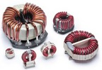
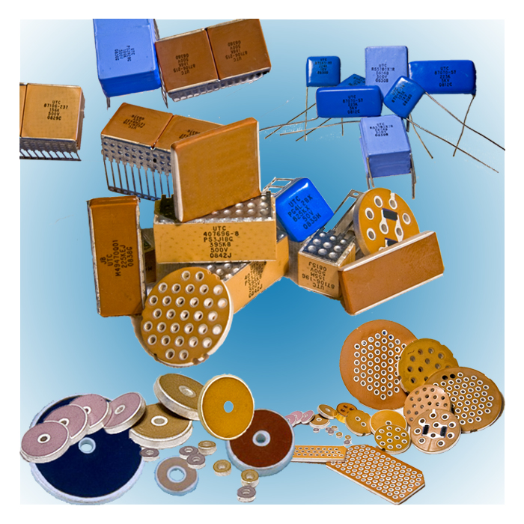
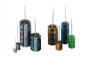
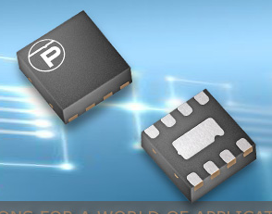

LINECARD

ELECTRICAL



Ultra low power ARM Cortex-M3 based microcontroller family.



EEPROMs, Power Regulation ICs, Digital Potentiometers.



Optoisolators and Optocouplers, Industrial and Hi-Rel



Wireless ICs, Legacy Technology ICs


Electrolytic, Tantalum, Solid Conductive Polymer and Double Layer & Film Capacitors


Custom Power supplies, DC/DC Converters


ICs for the conversion, transport and display of digital images. Features including video scaling, de-interlacing, warping, blending, and chroma-key

High Performance Transient Voltage Suppressors for Lightning and ESD Protection, PUNK Popup Noise Killer, Analog Switches

.
Standard & Custom Electro-magnetic Components including Planar Transformers & Current Sensors, Fluid Level & Proximity Sensors, Reed Switches & Relays


Thermistors / In-rush Limiters, MOVs, MLVs, GDTs, Piezo Ceramics, and NTC & PTC based Temperature Sensors


Mixed Signal ASICs, Clock generators Fanout Buffers, Logic Level Translators

(TaiSaw)
Crystals, Oscillators, VCOs, VCTCXOs, Crystal Filters, Ceramic Resonators, SAW Filters


Multilayer Ceramic Chip Capacitors & Radial leaded SMPS, High Voltage , Discoidals, Multipin Planar Arrays, thru wall EMI filters, Military & Commercial

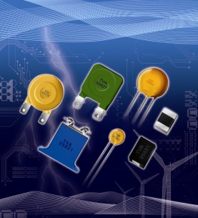
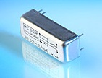
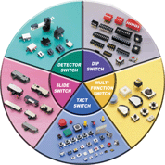
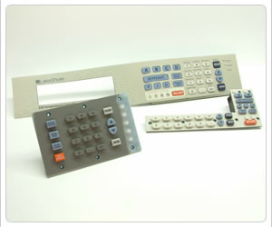
ELECTROMECHANICAL



Molding thermoplastics, thermoplastic elastomers, and thermoset materials. Short and long molding runs for commercial and government applications.

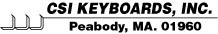
Membrane Switches and Overlays for commercial and military applications. Low to high volume.



Low cost DIP, tactile switches, slide switches, detector switches and multifunction switches


Printed Circuit Board fabrication, quick turn, volume, commercial, military, FR4, Polyimide, Kapton, TPreg, Teflon

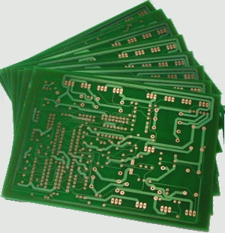


Spring pin contacts for test applications, and related custom connectors for battery, RF, lower resistance, high cycle rating, test probes


Wide variety of connector solutions including board-to-board, circular, rectangular, SIMM Card, FPC/FFC and coaxial ribbon cables, USB & HDMI



Low cost, LCDs, STN, TFT, Standard, Custom, backlit, extended temp range, modules, programming


Global manufacturer, JIT supplier of AC fans, DC fans, AC Fan trays, DC fan trays, specialty fans, fan accessories & blowers.


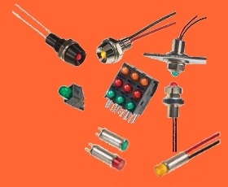
RNC90Y and NASA Type Bulk Metal Foil Resistors, LED Indicator Assemblies, Microswitches and Sealed Position Switches

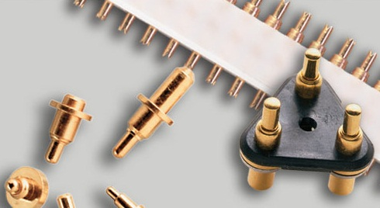

RF PRODUCTS
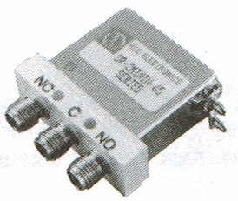
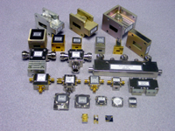



RF Amplifiers, Frequency Dividers, Isolators, Circulators, Waveguide adapters, Antennas, Oscillators (DROs), Pin Diode Switches, Mixers



Spring pin contacts for test applications, and related custom connectors for battery, RF, lower resistance, high cycle rating, test probes



High quality coaxial connectors and cable assemblies including formable and semi-rigid. Excellent service, cost competitive.


Precision Filters, Attenuators, Detectors, Switches, Power Dividers & Combiners, Couplers, Terminations to 65 GHz, DC Blocks, Bias Tees

Wireless ICs, PLLs

Clock generators ICs

(TaiSaw)
Crystals, Oscillators, VCOs, VCTCXOs, Crystal Filters, Ceramic Resonators, SAW Filters

STSCO Mission:

As a professional Manufacturers Representative, our goal is to provide quality solutions from a portfolio of complementary manufacturers. Through first class technical support and quick response support on all aspects of procurement, we aim to maximize our customers’ success in their development and production efforts.

STSCO Method:

- Our manufacturers can provide board level and box level solutions for all aspects of electronic and electrical design.
- We support all channels for procurement including direct and through distribution.
- Samples and pricing are available through our office.
- Literature and technical support are also provided.

Product Types

ASICs:
TLSI

Capacitors:
Nichicon (Electrolytics, Double Layer, Solid Conductive Polymer, Tantalum, Film)
Union Technology Corp. (Multilayer Ceramic)

Connectors/Cables:
Cernex
Interconnect Devices Inc. (IDI)
JAE
Koaxis

Fans:
Orion Fans

Isolation Devices:
Isolink

LED Assemblies:
Wilbrecht LEDCO Inc.

LCD Assemblies:
Orient Display (formerly AV LCD)

Magnetics:
Standex-Meder Electronics

Membrane Keypads:
CSI Keyboards

Memory:
Fremont Micro

Packaging:
APP

Power:
Apogee Power Sources
Powerstax

Printed Circuit Boards:
Electronic Interconnect

Protection Devices:
Protek Devices

Relays:
Standex-Meder Electronics

Resistors:
Wilbrecht LEDCO Inc.

RF Products:
Cernex (Amplifiers, Filters, etc.)
RLC Electronics
TAISAW / TST (Saw Filters)

Special Function ICs:
Fremont Micro
i-Chips
Protek Devices
TLSI

Switches:
Diptronics
Wilbrecht LEDCO Inc.

Timing:
TAISAW / TST

Video Processing:
i-Chips

