LINECARD

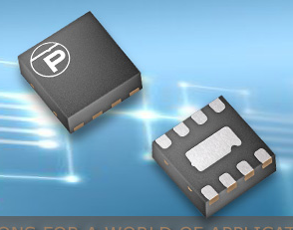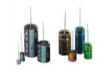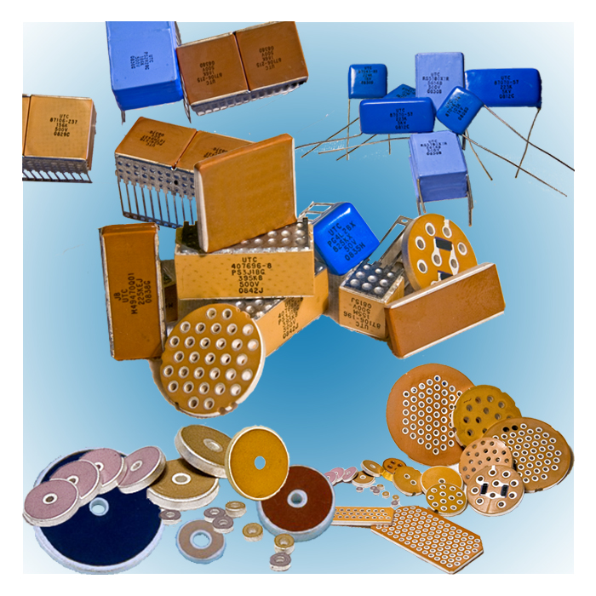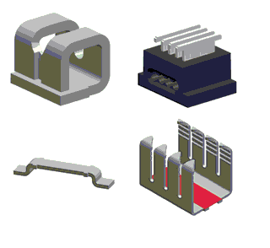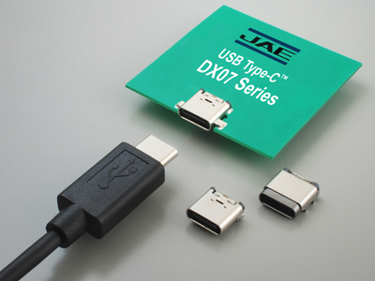

ELECTRICAL


Broad range of Serial NVRAM solutions, ASIC/IP and Embedded Solutions for IoT

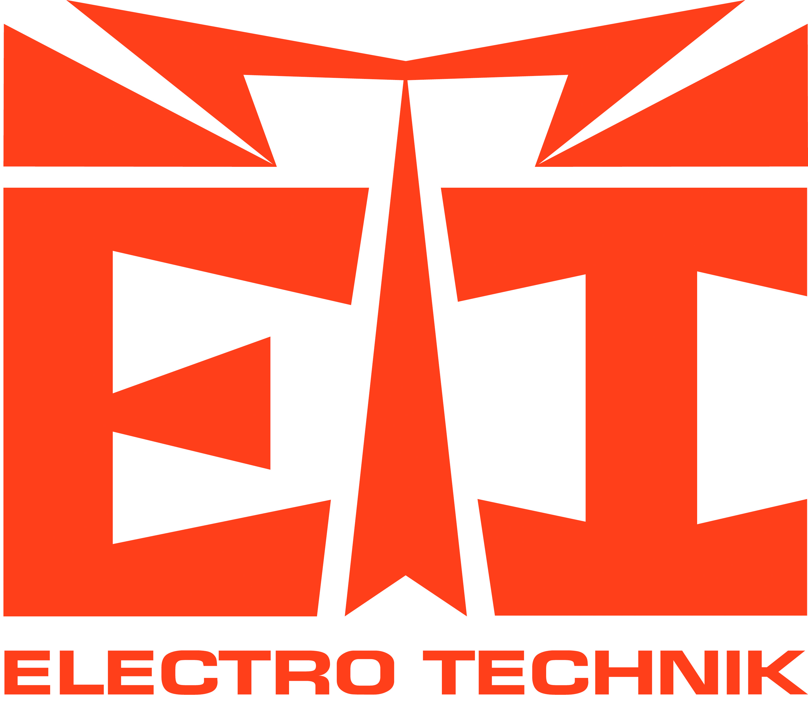
Broad range of passive components for medical, commercial, military & space level applications.


High Density MRAM, drop in replacements for SRAM, Serial Flash


Custom SoC ASIC Solutions


/

Optoisolators and Optocouplers, Industrial and Hi-Rel


Isolated and Non-Isolated High Efficiency DC/DC converters and related products


Aluminum Electrolytic, Solid Conductive Polymer Electrolytic, Double Layer & Film Capacitors

High Performance TVS Diodes

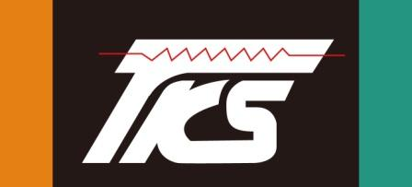 (Thinking Electronic)
Thermistors / In-rush Limiters, MOVs, MLVs, NTC & PTC based Temperature Sensors, Resettable Fuses & GDTs

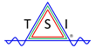
Low Power, High Fidelity, Mixed Signal Audio Semiconductor Solutions including CODECs and Class D Amplifiers, MFI

(TAISAW)
Crystals, Oscillators, VCOs, VCTCXOs, Crystal Filters, Ceramic Resonators, SAWs

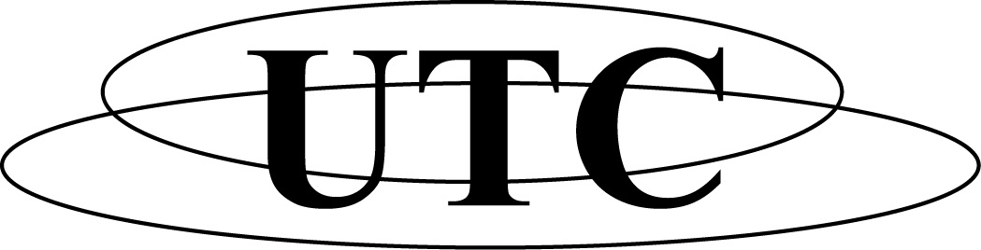
Multilayer Ceramic Chip Capacitors & Radial leaded SMPS, High Voltage , Discoidals, Multipin Planar Arrays, thru wall EMI filters, Military & Commercial


Hyperfast & Ultrafast Recovery Power Diodes, Power Schottky & Silicon Carbide Diodes, Triacs, SCRs, High Voltage Bipolar Transistors

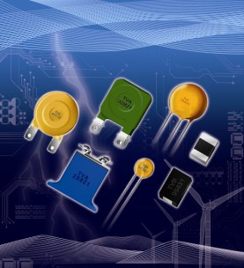
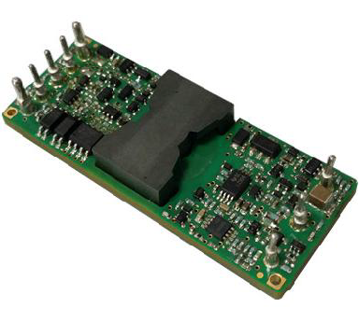
ELECTROMECHANICAL

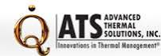
Standard and custom heat sinks/extrusions, retaining clips, thermal adhesives, thermal profiling instruments, related services

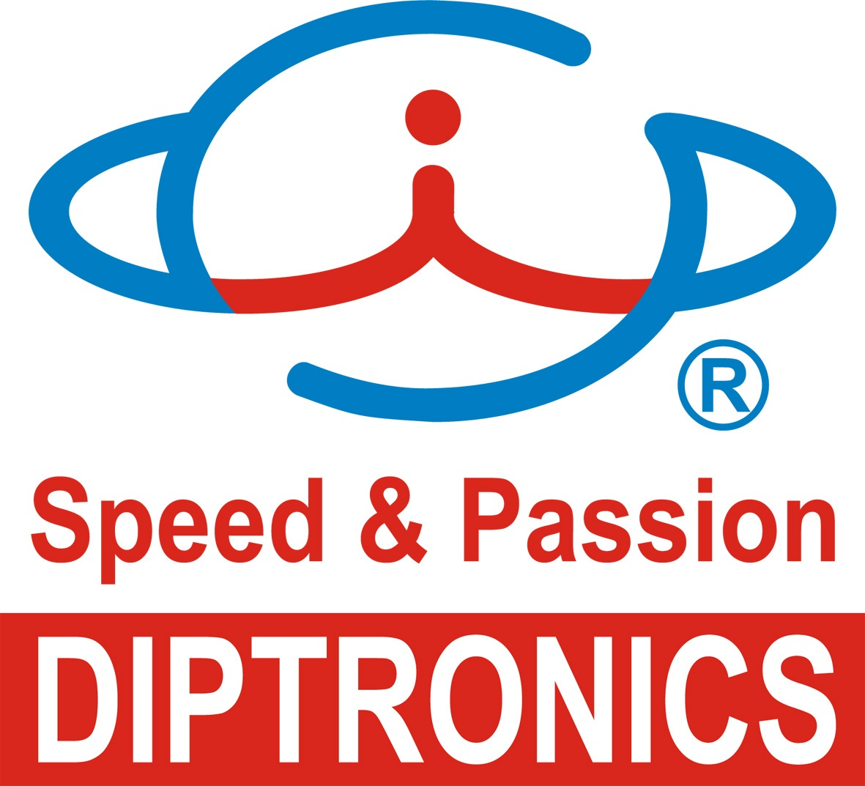

Low cost DIP, tactile switches, slide switches, detector switches and multifunction switches


High-quality LCD & OLED displays, monochrome TN/STN/FSTN LCM, COG LCD, TFT, FSC-LCD & OLED modules


Printed Circuit Board fabrication, quick turn, volume, commercial, military, FR4, Polyimide, Kapton, TPreg, Teflon


Wide variety of connector solutions including board-to-board, circular, rectangular, SIMM Card, FPC/FFC and coaxial ribbon cables, USB & HDMI


Global manufacturer, JIT supplier of AC fans, DC fans, AC Fan trays, DC fan trays, specialty fans, fan accessories & blowers


Numeric, Alpha-Numeric and discrete LEDs, LED strips, Custom LED Displays, Backlighting, Specialty, IR, UV, Power


Broad range of reed switches, reed and Hall Effect sensors


Global Leader in Flex PCB Manufacturing & Assembly of Flexible Printed Circuits


LED Indicators and Assemblies


Custom X86 Motherboards, Modified Bios, Single board computers - Tailored


Broad range of innovative interconnect solutions including IDC, IPC, terminal, tab & pin based approaches. Insertion equipment

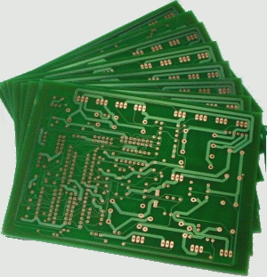
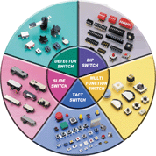

RF PRODUCTS
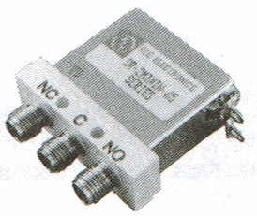

Hill Engineering
World leader in High Power Pin Diode Switch & Limiter Technology

Hermetic Sealed RF Diodes, RF Integrated assemblies, Skyworks Upscreened devices

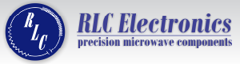

Precision Filters, Attenuators, Detectors, Switches, Power Dividers & Combiners, Couplers, Terminations to 65 GHz, DC Blocks, Bias Tees

 /
Ceramic filters, Advanced Dielectric and Magnetic Materials

(TAISAW)
Crystals, Oscillators, VCOs, VCTCXOs, Crystal Filters, Ceramic Resonators, SAW Filters

STSCO Mission:

As a professional Manufacturers’ Representative, our goal is to provide quality solutions from a portfolio of complementary manufacturers. Through first class technical support and quick response on all aspects of procurement, we aim to maximize our customers’ success in their development and production efforts.

STSCO Method:

- Our principals can provide board level, box level and system level solutions for all aspects of electronic and electrical design.
- We support all channels for procurement including direct and through distribution.
- Samples and pricing are available through our office.
- Literature and technical support are also provided.
Product Types

ASICs:
Faraday Technology

Audio:
Tempo Semiconductor

Capacitors:
Nichicon (Electrolytics, Double Layer, Solid Conductive Polymer, Tantalum, Film)
Union Technology Corp. (Multilayer Ceramic)
Electro Technik Inc.
Arizona Capacitor
Plastic Capacitor
CSI

Connectors/Cables/Interconnect:
JAE
PICA Manufacturing

Fans:
Orion Fans

Heat Sinks:
ATS

Isolation Devices:
Isolink

LEDs/Assemblies/Displays:
DLC Display
Para Light
Marl

Magnetics:
Electro Technik Inc.
Raycom
Hytronic
Winatic
I-Tech
Memory:
Adesto Technologies
Everspin Technologies

Power Conversion:
NetPower

Power Discretes (Thyristors, Diodes, Triacs & Transistors):
WeEn Semiconductors

Printed Circuit Boards:
Electronic Interconnect

Protection Devices:
Protek Devices
Thinking

Resistors:
Electro Technik Inc.
Tepro
Vamistor
Hymeg

RF Products:
Hill Engineering/Comtech
Isolink
RLC Electronics
TAISAW / TST (Saw Filters)
Trans-Tech, Inc.

Sensors:
PIC gmbh
Thinking Electronic

Switches:
Diptronics
PIC gmbh

Timing:
TAISAW / TST
Trans-Tech, Inc. (DROs)

